Email task

- Study the exercises (p 108).
- Do Ex 7 in writing. Mind the structure of the letter.
Use the phrases from the task.
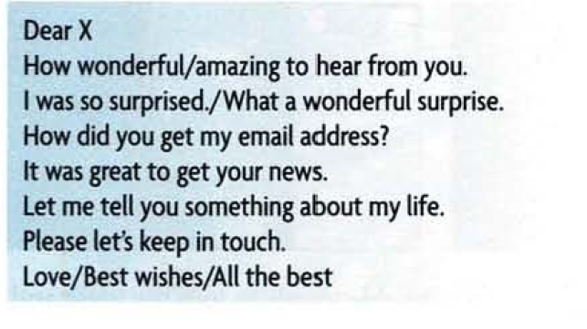
Use the linking elements (conjunctions).
Upload the letter to the course!

